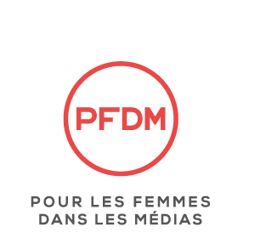

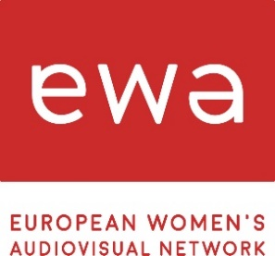

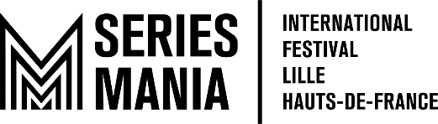

SERIES MANIA FORUM WITH
POUR LES FEMMES DANS LES MEDIAS (PFDM) AND
EUROPEAN WOMEN’S AUDIOVISUAL NETWORK (EWA)
ANNOUNCE THIS YEAR’S RECIPIENT OF ITS “WOMAN IN SERIES AWARD”

Nicola Shindler, Executive Producer and Chief Executive of Quay Street Productions, recipient of Third Annual “Woman in Series Award”
Announcement comes on March 8th being International Women's Day
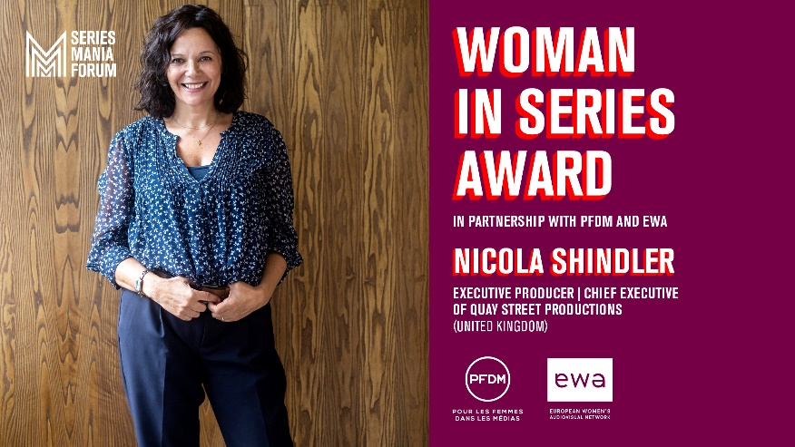
LILLE & PARIS, FRANCE – March 8, 2023 – Having launched as a new initiative in 2021, coupled with today being International Women's Day, Laurence Herszberg, Founder and General Director of Series Mania, and Francesco Capurro, Director of Series Mania Forum, announce the recipient for its Third Annual “Woman in Series Award.”

This award, in association with European Women’s Audiovisual Network (EWA Network) and Pour Les Femmes Dans Les Médias (PFDM), is given to a remarkable woman from the audiovisual industry to honor her vision and leadership. The recipient of this year’s award is Nicola Shindler, Executive Producer and Chief Executive of Quay Street Productions. Nicola Shindler will be presented with her award on March 21 in Lille. In addition, she will be speaking about her career that will look at the relationships she builds with writers, as well as her vision for producing engaging drama for a global audience.
“When we launched the ‘Woman in Series’ Award in 2021, our mission was to highlight and value the work of women within our industry as this is something that is incredibly important to me and close to my heart. I am incredibly honored to present Nicola with our award this year. As the founder of Quay Street Productions, coupled with her 25 years’ experience as a multi award-winning British television producer, Nicola is a true leader in every sense of the word and is certainly worthy of this wonderful award,” comments Laurence Herszberg.
Nicola Shindler says: “I’m really honoured to receive Series Mania’s Woman in Series Award. I love making drama, and to be recognised for my body of work is a privilege. I’ve been lucky enough to work with some of the most incredibly talented people – writers, producers, directors and so many more, who have enabled me to do so, and I have to thank them for their commitment and support. I’m excited for the next chapter with my new production company Quay Street Productions, having just launched our first drama, Nolly, and we’re in production on more exciting dramas.”
Laurence Bachman, President of the association Pour les Femmes dans les Médias comments: “Today, more than ever, we wish to salute, encourage, and reward inspiring women in business and media, with a recognized and remarkable career in the audiovisual industry. Still under-represented in the top leading functions (around 10%), this prize must value the place of women in the media industry and demonstrate that women must feel legitimate and dare. Celebrating those women is one of PFDM’s missions. We are thrilled to give this award to Nicola Shindler. She explores innovative stories working with new and established writers demonstrating her talent as a great producer.”

Anamaria Antoci, Executive Director of EWA says: “As a pan-European network for women working in the screen industries, we believe it is vital to highlight the creative and commercial successes of female producers and executives in an industry where women are still under-represented at all levels. In a career spanning over 25 years, Nicola Shindler has produced ground-breaking, entertaining, award-winning drama, from Queer as Folk, Last Tango in Halifax, and Happy Valley, to It’s a Sin, Harlan Coben’s Stay Close, and Nolly.”

Nicola Shindler’s inaugural drama under the Quay Street Productions, Nolly, will be presented as an out of competition screening at Series Mania. Quay Street Productions is part of ITV Studios.

Created in 2021, Woman in Series Award went to Christina Sulebakk, GM of HBO Max EMEA, for its first edition and in 2022 to Mo Abudu, CEO, The EbonyLife Group.

ABOUT NICOLA SHINDLER

Nicola Shindler OBE is a prolific, multi award-winning British television producer, who has worked with some of the most lauded names in television and created some of its most memorable series. With over 25 years’ experience in television, Nicola has produced some of the UK’s most successful and award-winning dramas, including It’s A Sin (Ch4/ HBO), Harlan Coben’s The Stranger (Netflix), Years and Years (BBC/HBO), Happy Valley (BBC), Queer As Folk (Channel 4), Ridley Road (BBC/ Masterpiece), Traces (UKTV), Last Tango in Halifax (BBC), Butterfly (ITV), Finding Alice (ITV) and most recently Harlan Coben’s Stay Close for Netflix, No Return for ITV, and Traces series 2 for UKTV.

Her latest drama series, the first Quay Street Productions drama, is Nolly. Written by Russell T Davies and starring Helena Bonham Carter, the series launched on ITVX in the UK on 3rd February. Forthcoming series include the comedic-drama Significant Other, starring Katherine Parkinson and Youssef Kerkour, also for ITVX. After the Flood for ITV, Harlan Coben’s Fool Me Once for Netflix and Men Up, a feature-length drama for BBC.

Renowned for her relationships with writers, Nicola has worked with an array of the UK’s most prolific and exciting writing talent including Russell T Davies, Sally Wainwright, Lenny Henry, Paul Abbot, Dan Sefton, Tony Marchant, Amelia Bullmore, Danny Brocklehurst, Matt Greenhalgh and Sarah Solemani, on series starring some of the world’s leading on-screen names.

In 2019, Nicola was awarded an OBE and took home one of BAFTA’s highest honours, the Special Award, for her services to British Broadcasting. Prior to launching Quay Street Productions in 2021, Nicola founded RED Production Company in 1998, where she was Chief Executive for over twenty years, and she also previously served as chief executive and chief creative officer at StudioCanal UK.

ABOUT QUAY STREET PRODUCTIONS (part of ITV Studios)
Quay Street Productions was founded by multi-award-winning producer Nicola Shindler OBE in 2021, to make contemporary, provocative, entertaining, and engaging drama for U.K. and global audiences. The new production company, which is part of ITV Studios, builds on Shindler’s reputation to deliver compelling drama, with her previous credits including It’s A Sin, Stay Close, Ridley Road, Finding Alice, The Stranger, Happy Valley and Queer As Folk. Based in Manchester, Quay Street Productions puts the writers and talent at the centre of the production process. Welcoming voices from all different backgrounds, Quay Street Productions promotes a diversity of storytelling working with new and established writers. Quay Street’s inaugural drama Nolly, written by Russell T Davies and starring Helena Bonham Carter, was released on ITVX in February 2023, and they are currently in production on Significant Other, written by Dana Fainaru and Hamish Wright and starring Katherine Parkinson and Youssef Kerkour, for ITVX, and After the Flood, written by Mick Ford for ITV, Harlan Coben’s Fool Me Once, with Danny Brocklehurst as lead writer, and Men Up, written by Matthew Barry.

ABOUT SERIES MANIA

Based in Lille since 2018, Series Mania - Lille / Hauts-de-France has become the biggest event dedicated uniquely to television series in Europe. Its festival offers exclusive world premieres of the greatest international series on the big screen, giving its audience - up to 70,000 spectators - 8 days of discoveries, parties, and masterclasses with some of the most renowned personalities in the series world. At the same time, Series Mania welcomes 3,300 professionals from over 64 countries at Series Mania Forum including the anticipated Lille Dialogues summit. Two key events for networking and business are now extended online with the creation in 2020 of Series Mania Digital. In 2021, Series Mania launched Series Mania Institute, a training program for students and industry professionals. The association is thus extending its action to support the creation of series in Europe.
https://seriesmania.com/en/

About PFDM

Created in 2012, the PFDM association aims to advance the place of women in the media, both in executive, creative and editorial positions. PFDM's goal is to bring together experienced media leaders and professionals who wish to ensure the visibility of women and their voices, to support the next generation of women in media and thus modernize the industry. http://www.pfdmedia.fr/

ABOUT EUROPEAN WOMEN’S AUDIOVISUAL NETWORK

The European Women's Audiovisual Network (EWA) connects female professionals working in the screen industries, in Europe and beyond. We champion gender equality, pay parity and inclusion in our sector, for all women, from all backgrounds. Our diverse and growing membership allows us to ground our campaigning work in the real-world concerns of women creating original content for cinemas, broadcasters and streaming platforms: https://www.ewawomen.com/

PRESS CONTACTS:

MORRIS MARKETING - USA
sheila@morrispr.com
Sheila MORRIS – 818-487-9300
danielle@morrispr.com
Danielle COTTON – 615-554-8671

MIAM - FRANCE
rpseriesmania@gmail.com
Blanche Aurore DUAULT - 06 29 97 88 89
Nathalie IUND - 06 10 96 30 08
Michael MORLON - 06 60 45 65 69

